Generic Blank Game Design Document (GDD)

***‘Space will be where you take your final breath ’*** – Efrain Vasques

This page: Table of Contents and Team Member Listing

|  |  |  |
| --- | --- | --- |
| Table of Contents  [1 Game Overview](https://n-xovwktmtjsnaxyc2mwes2xu7pohqedmdm6zjw5q-2lu-script.googleusercontent.com/userCodeAppPanel)  [2 High Concept](https://n-xovwktmtjsnaxyc2mwes2xu7pohqedmdm6zjw5q-2lu-script.googleusercontent.com/userCodeAppPanel)  [3 Unique Selling Points](https://n-xovwktmtjsnaxyc2mwes2xu7pohqedmdm6zjw5q-2lu-script.googleusercontent.com/userCodeAppPanel)  [4 Platform Minimum Requirements](https://n-xovwktmtjsnaxyc2mwes2xu7pohqedmdm6zjw5q-2lu-script.googleusercontent.com/userCodeAppPanel)  [5 Competitors / Similar Titles](https://n-xovwktmtjsnaxyc2mwes2xu7pohqedmdm6zjw5q-2lu-script.googleusercontent.com/userCodeAppPanel)  [6 Synopsis](https://n-xovwktmtjsnaxyc2mwes2xu7pohqedmdm6zjw5q-2lu-script.googleusercontent.com/userCodeAppPanel)  [7 Game Objectives](https://n-xovwktmtjsnaxyc2mwes2xu7pohqedmdm6zjw5q-2lu-script.googleusercontent.com/userCodeAppPanel)  [8 Game Rules](https://n-xovwktmtjsnaxyc2mwes2xu7pohqedmdm6zjw5q-2lu-script.googleusercontent.com/userCodeAppPanel)  [9 Game Structure](https://n-xovwktmtjsnaxyc2mwes2xu7pohqedmdm6zjw5q-2lu-script.googleusercontent.com/userCodeAppPanel)  [10 Game Play](https://n-xovwktmtjsnaxyc2mwes2xu7pohqedmdm6zjw5q-2lu-script.googleusercontent.com/userCodeAppPanel)  [10.1 Game Controls](https://n-xovwktmtjsnaxyc2mwes2xu7pohqedmdm6zjw5q-2lu-script.googleusercontent.com/userCodeAppPanel)  [10.2 Game Camera](https://n-xovwktmtjsnaxyc2mwes2xu7pohqedmdm6zjw5q-2lu-script.googleusercontent.com/userCodeAppPanel)  [10.2.1 HUD](https://n-xovwktmtjsnaxyc2mwes2xu7pohqedmdm6zjw5q-2lu-script.googleusercontent.com/userCodeAppPanel)  [10.2.2 Maps](https://n-xovwktmtjsnaxyc2mwes2xu7pohqedmdm6zjw5q-2lu-script.googleusercontent.com/userCodeAppPanel)  [11 Players](https://n-xovwktmtjsnaxyc2mwes2xu7pohqedmdm6zjw5q-2lu-script.googleusercontent.com/userCodeAppPanel)  [11.1 Characters](https://n-xovwktmtjsnaxyc2mwes2xu7pohqedmdm6zjw5q-2lu-script.googleusercontent.com/userCodeAppPanel)  [11.2 Metrics](https://n-xovwktmtjsnaxyc2mwes2xu7pohqedmdm6zjw5q-2lu-script.googleusercontent.com/userCodeAppPanel)  [11.3 States](https://n-xovwktmtjsnaxyc2mwes2xu7pohqedmdm6zjw5q-2lu-script.googleusercontent.com/userCodeAppPanel)  [11.4 Weapons](https://n-xovwktmtjsnaxyc2mwes2xu7pohqedmdm6zjw5q-2lu-script.googleusercontent.com/userCodeAppPanel)  [12 Player Line-up](https://n-xovwktmtjsnaxyc2mwes2xu7pohqedmdm6zjw5q-2lu-script.googleusercontent.com/userCodeAppPanel)  [13 NPC](https://n-xovwktmtjsnaxyc2mwes2xu7pohqedmdm6zjw5q-2lu-script.googleusercontent.com/userCodeAppPanel)  [13.1 Enemies](https://n-xovwktmtjsnaxyc2mwes2xu7pohqedmdm6zjw5q-2lu-script.googleusercontent.com/userCodeAppPanel)  [13.1.1 Enemy States](https://n-xovwktmtjsnaxyc2mwes2xu7pohqedmdm6zjw5q-2lu-script.googleusercontent.com/userCodeAppPanel)  [13.1.2 Enemy Spawn Points](https://n-xovwktmtjsnaxyc2mwes2xu7pohqedmdm6zjw5q-2lu-script.googleusercontent.com/userCodeAppPanel)  [13.2 Allies / Companions](https://n-xovwktmtjsnaxyc2mwes2xu7pohqedmdm6zjw5q-2lu-script.googleusercontent.com/userCodeAppPanel)  [13.2.1 Ally States](https://n-xovwktmtjsnaxyc2mwes2xu7pohqedmdm6zjw5q-2lu-script.googleusercontent.com/userCodeAppPanel)  [13.2.2 Ally Spawn Points](https://n-xovwktmtjsnaxyc2mwes2xu7pohqedmdm6zjw5q-2lu-script.googleusercontent.com/userCodeAppPanel)  [14 Art](https://n-xovwktmtjsnaxyc2mwes2xu7pohqedmdm6zjw5q-2lu-script.googleusercontent.com/userCodeAppPanel)  [14.1 Setting](https://n-xovwktmtjsnaxyc2mwes2xu7pohqedmdm6zjw5q-2lu-script.googleusercontent.com/userCodeAppPanel)  [14.2 Level Design](https://n-xovwktmtjsnaxyc2mwes2xu7pohqedmdm6zjw5q-2lu-script.googleusercontent.com/userCodeAppPanel)  [14.3 Audio](https://n-xovwktmtjsnaxyc2mwes2xu7pohqedmdm6zjw5q-2lu-script.googleusercontent.com/userCodeAppPanel)  [15 Procedurally Generated Content](https://n-xovwktmtjsnaxyc2mwes2xu7pohqedmdm6zjw5q-2lu-script.googleusercontent.com/userCodeAppPanel)  [15.1 Environment](https://n-xovwktmtjsnaxyc2mwes2xu7pohqedmdm6zjw5q-2lu-script.googleusercontent.com/userCodeAppPanel)  [15.2 Levels](https://n-xovwktmtjsnaxyc2mwes2xu7pohqedmdm6zjw5q-2lu-script.googleusercontent.com/userCodeAppPanel)  [15.3 Artificial Intelligence NPC](https://n-xovwktmtjsnaxyc2mwes2xu7pohqedmdm6zjw5q-2lu-script.googleusercontent.com/userCodeAppPanel)  [15.4 Visual Arts](https://n-xovwktmtjsnaxyc2mwes2xu7pohqedmdm6zjw5q-2lu-script.googleusercontent.com/userCodeAppPanel)  [15.5 Audio](https://n-xovwktmtjsnaxyc2mwes2xu7pohqedmdm6zjw5q-2lu-script.googleusercontent.com/userCodeAppPanel)  [15.6 Minimum Viable Product (MPV)](https://n-xovwktmtjsnaxyc2mwes2xu7pohqedmdm6zjw5q-2lu-script.googleusercontent.com/userCodeAppPanel)  [16 Wish List](https://n-xovwktmtjsnaxyc2mwes2xu7pohqedmdm6zjw5q-2lu-script.googleusercontent.com/userCodeAppPanel)   |  | | --- | |  | | Game Development Team Members    PRODUCER  Efrain Vasques    PRODUCTION MANAGER  Efrain Vasques    PRODUCTION COORDINATOR  Efrain Vasques  GAME DESIGNERS  Efrain Vasques  SYSTEMS/IT COORDINATOR  Efrain Vasques  PROGRAMMERS  Efrain Vasques  TECHNICAL ARTISTS  Efrain Vasques  AUDIO ENGINEERS  Efrain Vasques  UX TESTERS  Efrain Vasques |

|  |
| --- |
|  |

# 1 Game Overview

Title: **Final Space**

Platform: PC Standalone

Genre: 2D Space Survival Shooter

Rating: (10+) ESRB

Target: Everyone

Release date: April, 2020

Publisher: EV Studios

Description: Final Space is a top-down 2D endless survival shooter arcade game, where you are the last line of defense against a militant and brutal alien race. They are dubbed the “Ravagers”. You and your squadron have been ambushed and you are the sole survivor, in the path of a massive Ravager invasion fleet. You are piloting a close-range light attack fighter, equipped with a blaster. The player must kill as many of the Ravagers as they can. The more the player progresses through the levels, the more enemies will show up to try and squash whatever resistance they find, at all costs. The player is much more nimble and faster than the enemy ships initially. But as the enemy becomes more and more frustrated in not being able to kill the player, they will send more ships and increase their rate of fire to trap the nimble human ship in a tsunami of deadly energy projectiles.

# 2 High Concept

Final Space sets the player in space, lightyears away from planet Earth, near a patrol base. An enemy invasion fleet composed of different types of ships are headed to Earth to enslave and capture what is left of humanity. Using speed, agility, and determination, the player will wipe out any Ravager scum. Blasting them with their laser cannon into pieces, ensuring one less Ravager gets to set foot on your precious home world of Earth.

# 3 Unique Selling Points

Unique and original artwork

Unique original story

# 4 Platform Minimum Requirements

OS: Windows XP SP2, GPU: DX9 (shader model 2 .0) capabilities; anything made since 2003 should work

# 5 Competitors / Similar Titles

Bullet Hell Monday by MAYASUKI ITO

# 6 Synopsis

Your civilization (humans) and another named the "Ravagers" have been at war and conflict for hundreds of years. Peace talks were considered initially but were quickly dismissed as soon as the diplomatic envoy were...well, for the lack of a better term, ravaged and killed as soon as they got within shooting distance.

Unfortunately, your side has been losing for the past hundred years, as the Ravagers are a primarily a militant race. Specializing in the art of war for much longer than humanity has been existing.

You were on a routine patrol when suddenly, you and your squadron were ambushed and swiftly annihilated by what seems to be a gargantuan invasion fleet. One way that the Ravagers maintain a steady labor force is by dominating and enslaving the losing opponent race. They have now decided to proceed to your home world planet with an invasion fleet. Seeing how humanity is on its last legs, why not?

Through the sacrifice of a squad mate, you are able to escape just barely. You quickly proceed back to base to warn others and send a message back to Earth about the impending invasion. Only to find it already destroyed upon returning. While you do have a communication system, it is not powerful enough to send a message that can travel fast enough back to Earth to give them enough time to initiate the evacuation procedure. For it was thought inevitable that the Ravagers would finally approach Earth. If only your short-range fighter had FTL capabilities. Back at base, there is a transport ship that can travel at light speed, except now it has been blown to scrap.

Communication to and from home using the ship's communication system would take literal months, no way to get home back in time to warn them and allow evacuation preparations to take place. Only one thing to do in a last-ditch effort to help lessen the impact of the invasion force, make a final last stand and take as many of those Ravager bastards with as you can. Every Ravager dead is one less alien filth that will step foot on Earth to rape, pillage, and enslave your fellow friends, family, and comrades back home.

To maximize damage, hit and run tactics will be used. Going to different sectors to destroy ships group by group. They will soon catch wind of the tactics and proceed to attack you with more ships.

# 7 Game Objectives

The goal is for the player to kill as many enemy ships as possible, while dodging enemy projectiles and suicide ships.

# 8 Game Rules

The game levels are enclosed in a square region of space. Where the enemy ships appear en masse to the left of the area. The player can shoot them with a laser cannon that can be pointed with the mouse in a 360 degree field of view and fire. The player can move in any direction in the 2D plane the ship is in. Every time a player kills all enemies spawned, another level with a different background will be loaded. Where more enemies will spawn and have increased speed and rate of fire.

# 9 Game Structure

# 10 Game Play

## 10.1 Game Controls

**Game Controls (PC)**

Keyboard: Esc (Pause in-game)

W (Move up), A (Move left), S (Move down), D (Move right)

Mouse: Left mouse button (Fire cannon)

## 10.2 Game Camera

When playing, the camera will be static, looking over the level. Remaining static the entirety of the game. The background is also be static and will be seen from a top-down perspective.

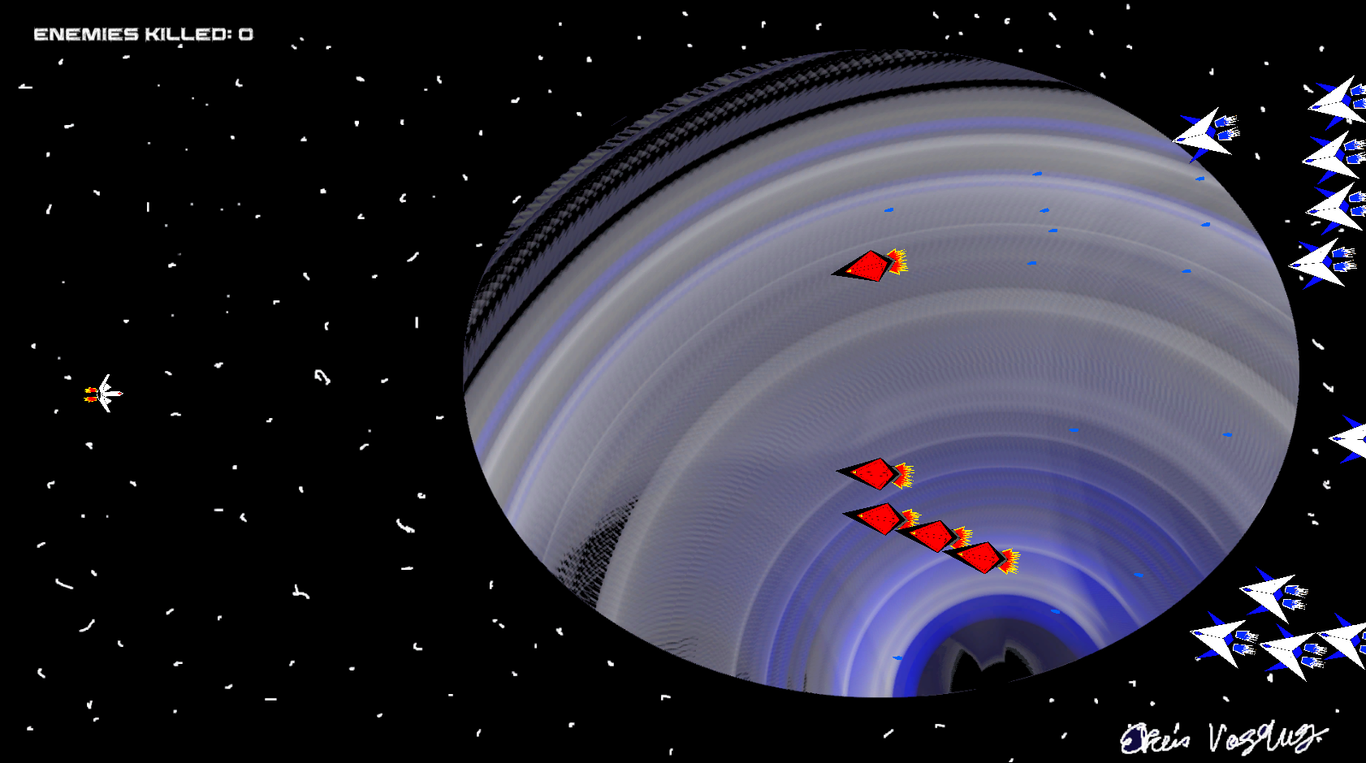

### 10.2.1 HUD

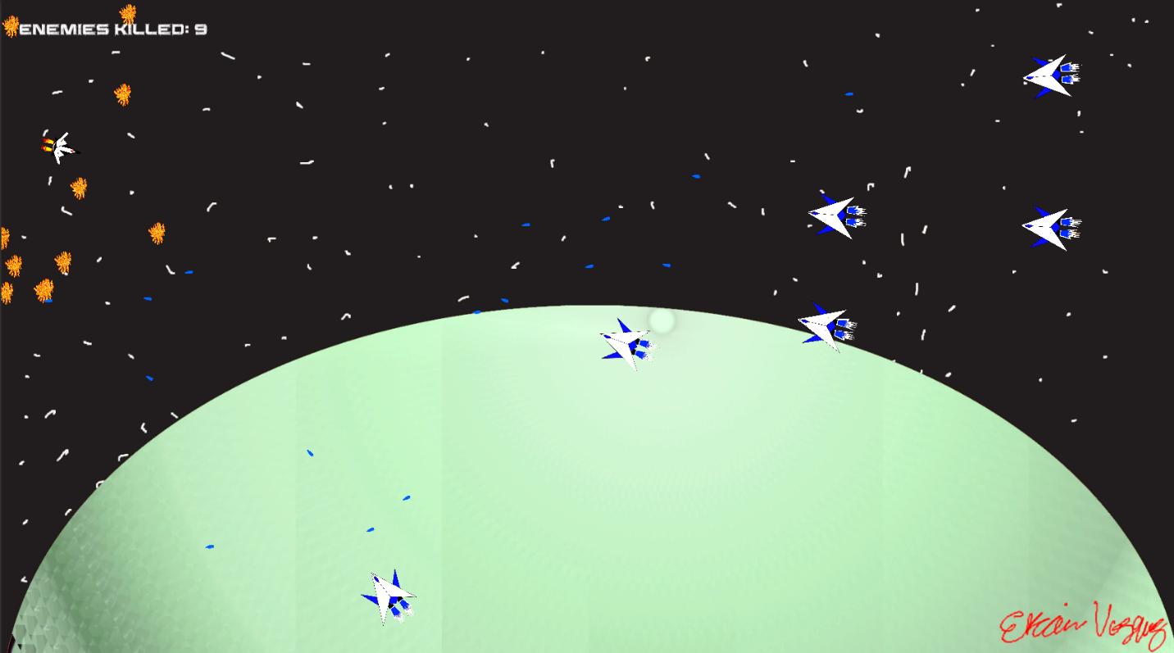

Enemies Killed

Indicates the amount of enemy ships destroyed.

### 10.2.2 Maps

There are three levels with different backgrounds.

# 11 Players

## 11.1 Characters

The player is an unnamed lone space fighter pilot that was quickly drafted into service since humanity is on its last legs of the war. Unfortunately, a massive Ravager invasion fleet is passing through his patrol sector. On its way to finally conquer Earth, the player will make sure to take as many of them as possible before going down in a blaze of glory.

## 11.2 Metrics

**Player**

Speed: 5.0

Health: N/A

Attack Damage: N/A

Rate of fire: Semi-automatic, as fast as the fire button is pressed.

## 11.3 States

Idle: No cycle animation, ship will be standing still with the afterburners on

Move: No cycle animation, ship will be rotation and facing towards the mouse cursor.

Death: Ship will emit explosion spark sprite around and will disappear after a few seconds of being hit.

## 11.4 Weapons

The player only has one weapon, a laser cannon that shoots red laser projectiles. Can kill with one shot. No cooldown needed, can be fired at will as fast as the player can click.

# 12 Player Line-up

The player will be a lone surviving pilot. Flying around a close-range light attack reconnaissance ship.

# 13 NPC

## 13.1 Enemies

There are three types of enemies, two that shoot and one that rams into the player. They can all kill the player with one hit. They can also die from one hit. Enemies are spawned at random locations to the left of the screens all at once so to speak. Hoping to instill shock and awe at the display of numbers and firepower as waves upon waves of Ravagers descend onto the poor victims.

**Basic Ravager Fighter**

The basic fighter is the back bone of the Ravager space force. It’s pilots are indoctrinated to engage at a distance and make the opponent dance with its deadly blaster.

Speed: 2.0

Health: N/A

Score Value: 1

Attack Damage: N/A

Rate of fire: 1.5

**Explosive Ravager Suicider**

This ship is used and piloted by those that are enslaved in the Ravager war campaigns. They are surgically modified to feel constant pain and are promised salvation from it, in death. Victims so desperate to die, that they are more than willing to do so, even if fighting against their own allies and comrades. Anything to end the torment and suffering.

**Elite Ravager Fighter**

These types of ships are more deadly and dangerous than their basic fighter counterparts. Featuring twin-linked plasma cannons, they can put down a volley of fire down range to overwhelm and disintegrate anything in their path.

### 13.1.1 Enemy States

Both ranged fighters possess the same behavior of staying at a distance to pepper the player with lethal energy projectiles. Facing and shooting at the player, seeking to destroy the last bit of human resistance.

Whereas the suicide goes ahead and closes in on the player to ram and explode on contact.

Idle: The enemies will stand down and stop facing or looking at the player when he or she is destroyed.

Move: While the player is alive, the enemies will converge towards the player.

Death: The enemy ships will explode and die upon being hit from the player’s projectiles.

### 13.1.2 Enemy Spawn Points

Each enemy will spawn at random points at the furthermost left side of the screen. Appearing all at once.

**Basic Ravager Fighter**

Initial Spawn Amount: 10 (increases by one after the first level)

Maximum Spawn Amount: N/A (They just keep coming!)

**Explosive Ravager Suicider**

Initial Spawn Amount: 5 (Increases by one after the first level)

Maximum Spawn Amount: N/A (More than Earth’s population)

**Elite Ravager Fighter**

Initial Spawn Amount: 0 (Increases by two each level)

Maximum Spawn Amount: N/A (No one has survived long enough to actually count them)

## 13.2 Allies / Companions

None, they all died in the ambush.

### 13.2.1 Ally States

N/A

### 13.2.2 Ally Spawn Points

N/A

# 14 Art

## 14.1 Setting

Takes place in space at different locations near the Milky Way galaxy.

## 14.2 Level Design

There are three wall barriers preventing the player to fly off the level area. At the left, top, and bottom of the screen.

## 

## 14.3 Audio

|  |  |  |  |
| --- | --- | --- | --- |
| Name | Category | Description |  |
|  |  |  |
| Bomb+1 | FX | Plays when a ship is destroyed |  |
| Laser_Cannon-Mike_Koenig-797224747 | FX | Implemented, but edited, See below. |  |
| Laser_Cannon_Mike_Koenig_Shortened | FX | Edited version, Player shoots laser cannon |  |
| POL-combat-plan-short | Background music | Planned, but not implemented |  |
| POL-galactic-trek-short | Background music | Planned, but not implemented |  |
| POL-nuts-and-bolts-short | Background music | Plays during the game |  |
| ray_gun-Mike_Koenig-1169060422 | FX | Implemented, but edited. See below. |  |
| Ray_Gun_Mike_Koenig_Shortened | FX | Edited version, enemy ships shooting |  |
|  |  |  |  |

# 15 Procedurally Generated Content

## 15.1 Environment

N/A

## 15.2 Levels

N/A

## 15.3 Artificial Intelligence NPC

Enemies face the player and close in. If they are a shooter variant, they move and stop at a distance away from the player. Otherwise, if they are a suicide, they will proceed to ram into the player.

## 15.4 Visual Arts

N/A

## 15.5 Audio

N/A

## 15.6 Minimum Viable Product (MPV)

One ship to choose from and basic moving and shooting.

Only three types of enemies

Static levels with no type of dynamic hazards or obstacles.

No inventory system for power ups

No power ups

No high score saving system

Only built for PC (Windows)

Only one song throughout the whole game

# 16 Wish List

Power ups

Different player ship types to choose from

Inventory system to store power ups

More varied enemy types and attacks

Voice acting

More background music